challenge

lesson 7 problem+challenge:  
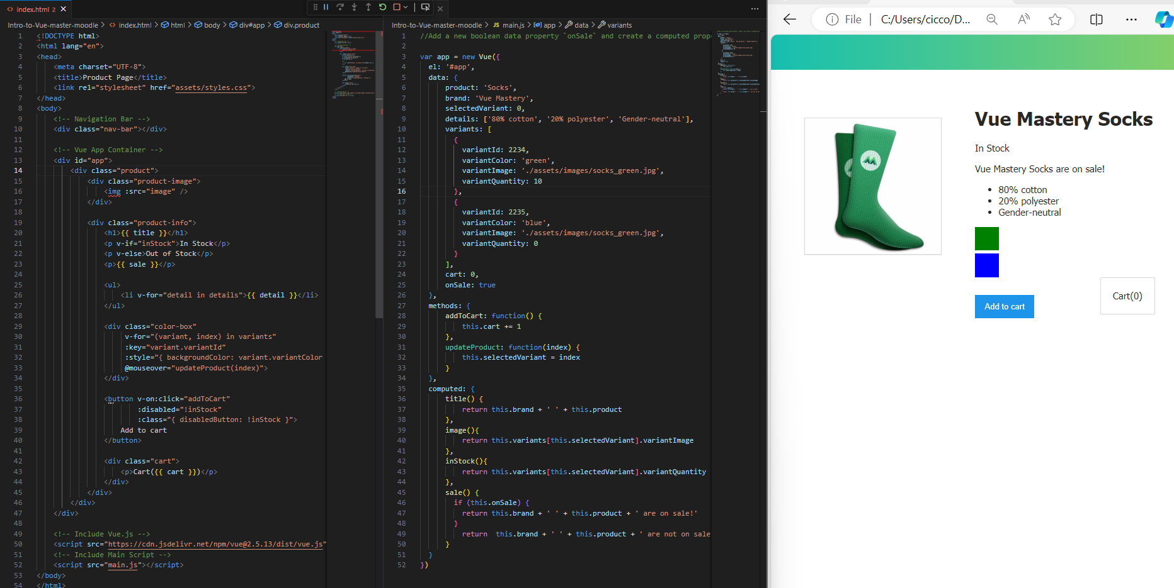

200 words:

Week 4 focused on advanced Vue.js concepts such as event handling, class and style binding, and computed properties. These concepts enable developers to create more dynamic and interactive applications.

Event handling in Vue.js is achieved through the v-on directive (or its shorthand @). This allows developers to bind DOM events, such as clicks or form submissions, to methods in their Vue instance. When an event is triggered, the associated method is executed, which helps in managing user interactions seamlessly.

Class and style binding in Vue provides a way to dynamically apply CSS classes and inline styles based on data properties. By using v-bind:class and v-bind:style, developers can conditionally change the appearance of HTML elements. This ensures that the UI adapts automatically in response to changes in the application’s state.